Department of Information Science & Engineering



A Report

On

“Study Buddy”
Minor Project (BIS586)

Submitted By

Prasanna BS 4NI22IS152

Rakesh Baleri 4NI22IS166

Ranjith HK 4NI22IS168

Sangam Gowda HM 4NI22IS187

Under the Guidance of

Manasa U

Assistant Professor



The National Institute of Engineering

(Autonomous Institution under Visvesvaraya Technological University)

MYSURU – 570018

2024-25

The National Institute of Engineering
Department of Information Science and Engineering
MYSURU- 570018




Certificate

Certifies that the Minor-Project titled “Study Buddy” is presented by Prasanna, Rakesh, Ranjith, Sangam bearing USN 4NI22IS152 4NI22IS166 4NI22IS168 4NI22IS187 in partial fulfillment for the requirements of the fifth semester BE in Information Science & Engineering prescribed by The National Institute of Engineering, Autonomous Institution under Visvesvaraya Technological University, Belagavi. It is certified that all corrections/suggestions indicated for Internal Assessment have been incorporated. The minor project report has been approved as it satisfies the academic requirements in respect of the minor project prescribed for the fifth semester.

Signature of Guide Signature of HOD
Manasa U Dr. Girish
Associate Professor HoD & Professor
NIE, Mysuru NIE, Mysuru

ACKNOWLEDGEMENT

The success and the final outcome of this minor project presentation required a lot of guidance and assistance from many people and I am extremely fortunate to have got this all along with the completion of the minor project presentation.
I express my profound thanks to Dr. Rohini Nagapadma, Principal, NIE, Mysuru for her much needed moral support and encouragement.
I am grateful to Dr. Girish, HoD, & Professor, Information Science and Engineering, NIE for his support and encouragement in facilitating the progress of this work.
I sincerely extend my thanks to the minor project Coordinators Dr. Rajeshwari D, Associate Professor, and Ms. Manasa K.B, Assistant Professor.
I would like to sincerely thank my Guide Dr. Rajeshwari D, Associate Professor in the Dept. of I.S.&E., for her guidance, technical expertise, encouragement, and timely help in making this work a reality.
Also, I would like to extend my sincere regards to all the non-teaching staff of the IS&E Dept. for their timely support.

Prasanna BS
4NI22IS166

TABLE OF CONTENTS

CHAPTERS PAGE NO
CHAPTER 1: INTRODUCTION
  - Introduction 2
  - Scope of Work 5
  - Importance and relation to previous work and the present Developments 6
CHAPTER 2: LITERATURE SURVEY 7
CHAPTER 3: SYSTEM ANALYSIS
  - Introduction 10
  - Problem Definition/Framework 10
  - Proposed Methodology/Design Methodology 11
  - System Requirements 12
CHAPTER 4: SYSTEM DESIGN
  - Use case diagrams 13
  - Flowchart 15
CHAPTER 5: SYSTEM IMPLEMENTATION
  - Introduction 17
  - Implementation of Proposed Methodology 17
CHAPTER 6: RESULTS AND DISCUSSION
CONCLUSION WITH FUTURE ENHANCEMENTS 25
BIBLIOGRAPHY 34

ABSTRACT

The Study Buddy project focuses on developing a responsive web application that provides students with a centralized platform to explore, enroll in, and track their progress across various academic courses. Built using the MERN stack (MongoDB, Express.js, React.js, and Node.js), this project combines robust backend functionality with an intuitive, user-friendly frontend to deliver an efficient and scalable solution tailored for modern educational needs. With its responsive design, the platform ensures seamless navigation across desktops, tablets, and mobile devices, allowing students to access key features such as a detailed course catalog, personalized profile management, and real-time progress tracking. The platform offers a user-friendly interface for browsing courses, complete with descriptions, schedules, and pricing, alongside tools for students to manage profiles, update preferences, and review enrolled courses. Additionally, the application enables students to monitor their academic progress by tracking completed modules, viewing performance metrics, and receiving course recommendations. Leveraging the MERN stack, Study Buddy ensures fast content rendering, secure data handling, and dynamic performance, offering an engaging and personalized learning experience. By bridging the gap between students and accessible learning resources, Study Buddy promotes academic growth, fosters continuous learning, and empowers students with the tools they need for success in their educational journey.

CHAPTER 1 INTRODUCTION

Introduction
The advent of technology has revolutionized the education sector, paving the way for innovative tools that enhance the learning experience. Study Buddy is a web-based application designed to address the growing demand for accessible, flexible, and user-friendly learning platforms. With an emphasis on bridging the gap between students and educational resources, this project aims to provide an all-encompassing solution for exploring, enrolling in, and tracking progress across various courses. By leveraging the power of the MERN stack (MongoDB, Express, React, and Node.js), the application offers a seamless and responsive interface, catering to the academic needs of diverse users. The platform not only promotes self-paced learning but also empowers students with insights into their performance and progress, fostering a culture of continuous education.
Moreover, Study Buddy serves as an educational ecosystem where students can engage with their learning materials in an organized manner. By utilizing cloud-based technologies, the platform ensures that users can access their courses and data from anywhere, providing the flexibility required for modern education. The application aims to democratize education by breaking down barriers such as geographical limitations and high costs, making quality learning accessible to all. Through its intuitive design and robust functionalities, Study Buddy is set to redefine how students interact with digital learning environments.
1.2 Scope of Work
The scope of Study Buddy is extensive, encompassing the development of a robust and scalable web application tailored for educational purposes. The project includes designing a user-friendly interface for students to browse courses, enroll, and monitor their progress. Additionally, it involves creating a responsive design compatible with various devices, ensuring an optimal user experience. The backend architecture supports efficient data handling, user authentication, and secure storage of information. Key features such as course recommendations, personalized dashboards, and progress tracking tools are integrated to enhance usability. Moreover, the application’s modular design allows for future scalability, enabling the addition of new features such as real-time feedback, peer interactions, and certification upon course completion.

1.3 Importance and Relation to Previous Work and Present Developments
Study Buddy stands out in its ability to combine advanced technologies with the growing need for digital education platforms. While previous educational tools have focused on specific aspects such as content delivery or progress tracking, this project integrates these functionalities into a single cohesive platform. The use of the MERN stack ensures optimal performance and responsiveness, addressing the limitations of older systems. Furthermore, Study Buddy aligns with current developments in e-learning by adopting a personalized approach, catering to individual learning styles and preferences. By doing so, it not only enhances the overall user experience but also contributes to the broader goal of making quality education accessible to all.
In the context of present developments, Study Buddy embraces emerging trends such as microlearning and gamification to make education engaging and effective. By including elements like progress badges, interactive quizzes, and leaderboards, the platform encourages active participation and motivates learners. Additionally, its compatibility with various digital devices ensures that the platform meets the needs of a tech-savvy generation, making it a relevant and timely solution.

CHAPTER 2

LITERATURE SURVEY

The concept of online learning has evolved significantly over the years, driven by advancements in technology and changing educational needs. Numerous studies highlight the effectiveness of web-based platforms in improving student engagement and learning outcomes. Early systems, such as Learning Management Systems (LMS), provided basic functionalities like course management and content delivery. However, they often lacked the flexibility and interactivity required for modern learners. Recent developments in e-learning platforms, such as Coursera and Udemy, have addressed these gaps by offering diverse courses, interactive interfaces, and progress tracking tools.

The literature reveals that personalized learning is a critical factor in enhancing the effectiveness of online education. Studies indicate that platforms capable of adapting to individual learning styles and providing tailored recommendations significantly improve user engagement and retention rates. Furthermore, the integration of advanced technologies, such as artificial intelligence and data analytics, has opened new possibilities for creating intelligent learning systems.

Despite these advancements, challenges remain in ensuring accessibility, scalability, and affordability. Study Buddy aims to address these issues by leveraging the MERN stack to create a cost-effective and user-friendly solution. By integrating best practices from existing platforms and incorporating innovative features, this project seeks to set a new standard for online learning applications.

Furthermore, a critical analysis of existing literature highlights the need for platforms that offer a holistic learning experience. While many systems focus solely on content delivery, Study Buddy aims to provide a comprehensive ecosystem that includes community interactions, feedback mechanisms, and tools for self-assessment. By doing so, it aligns with educational theories that emphasize active learning and peer collaboration, ensuring that users not only consume information but also engage with it meaningfully.

CHAPTER 3

SYSTEM ANALYSIS

3.1 Introduction

System analysis is a crucial step in the development process, providing a detailed understanding of the project’s requirements, challenges, and potential solutions. For Study Buddy, this involves analyzing user needs, identifying technical requirements, and designing a framework that ensures optimal functionality and user experience.

3.2 Problem Definition/Framework
The primary problem addressed by Study Buddy is the lack of a centralized platform that combines course exploration, enrollment, and progress tracking in a seamless manner. Existing solutions often fall short in providing an intuitive interface, real-time progress monitoring, and personalized recommendations. The framework for Study Buddy is designed to overcome these limitations by integrating these features into a cohesive platform.
The problem definition also includes addressing the need for scalability and flexibility to cater to a growing user base. As educational demands evolve, the platform must be capable of incorporating new technologies and adapting to changing user preferences. This requires a robust design that balances functionality with ease of use, ensuring that users of all technical skill levels can benefit from the platform.

3.3 Proposed Methodology/Design Methodology
The proposed methodology involves a user-centric approach, focusing on creating a responsive and intuitive interface backed by a robust backend architecture. The development process includes:
- Requirement gathering and analysis
- Design of the frontend and backend systems
- Implementation of key features using the MERN stack
- Testing for performance, usability, and scalability
- Deployment and maintenance

3.4 System Requirements
The system requirements for Study Buddy are categorized as follows:
Hardware Requirements:
- Minimum i5 processor laptop
- 8 GB RAM
- 256 GB SSD storage
- Stable internet connection
Software Requirements:
- Windows 10 operating system
- Node.js for backend development
- MongoDB for database management
- React.js for frontend development
- Express.js for API handling
- Development tools such as VS Code and IntelliJ

CHAPTER 4

SYSTEM DESIGN

4.1 Use Case Diagrams
Use case diagrams provide a visual representation of the system’s functionalities and interactions between users and the system. For Study Buddy, the primary use cases include:
- User registration and login
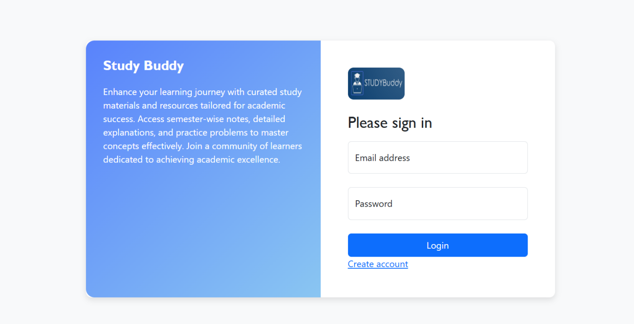
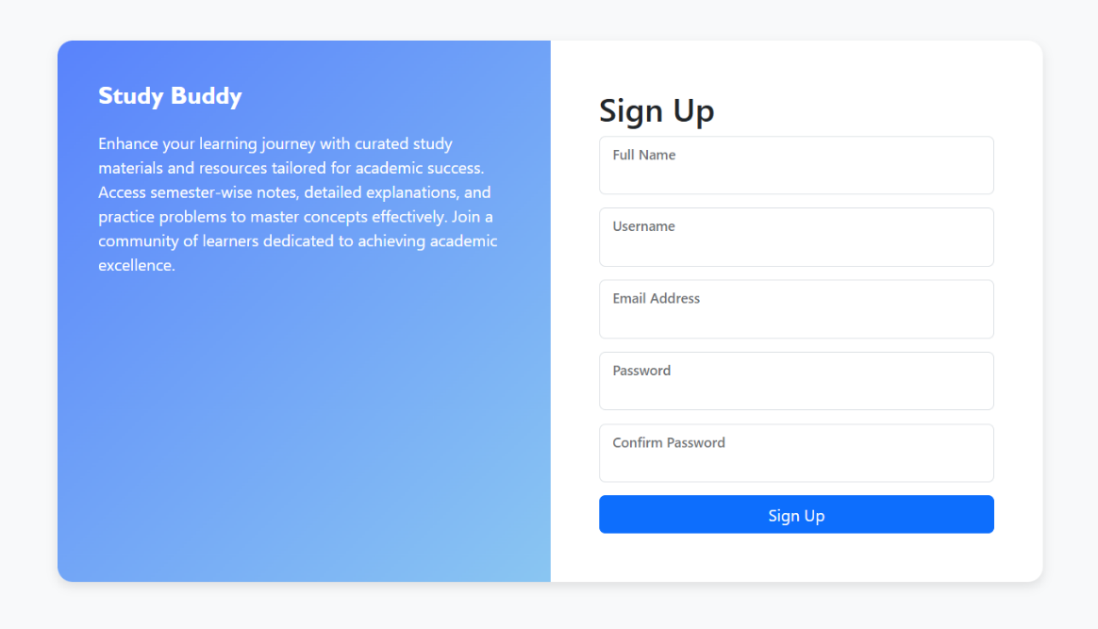

- Browsing available courses

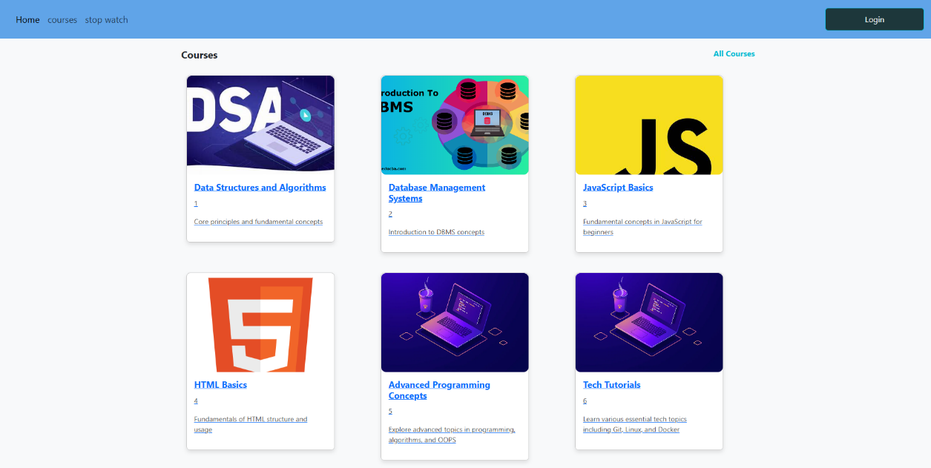
- Enrolling in courses
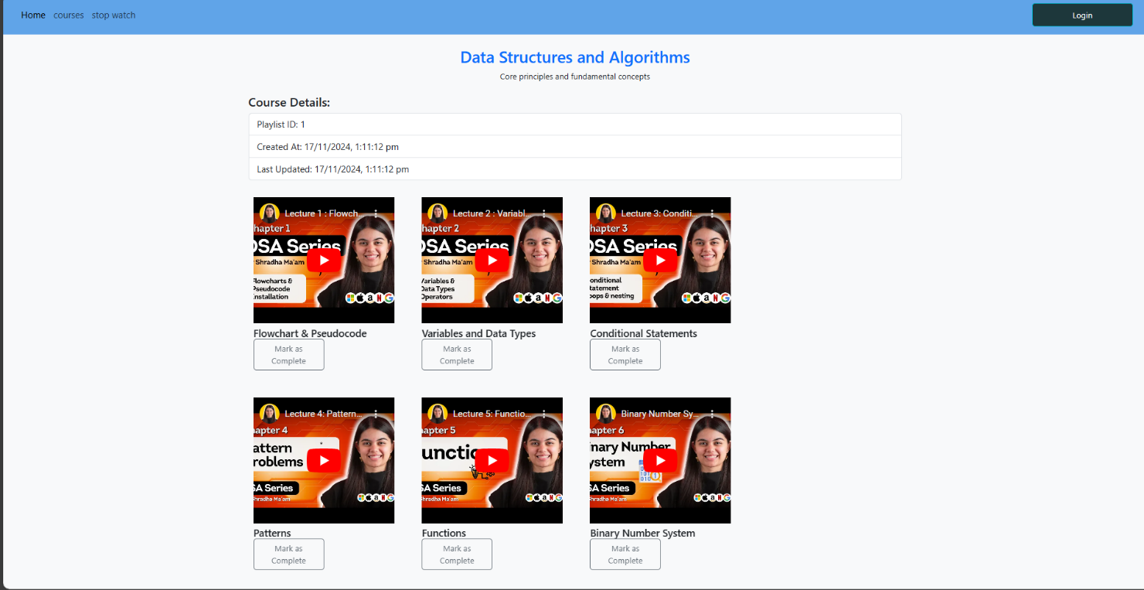

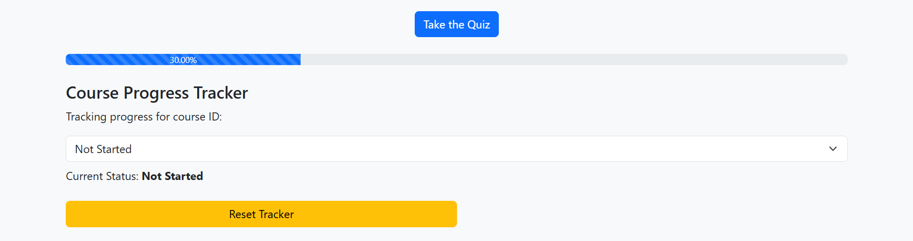
- Tracking course progress

4.2 Flowchart
The flowchart illustrates the workflow of the application, starting from user authentication to course completion. It includes decision points for actions such as course enrollment, profile updates, and progress tracking. The flowchart ensures clarity in the system’s processes, aiding in efficient development and troubleshooting
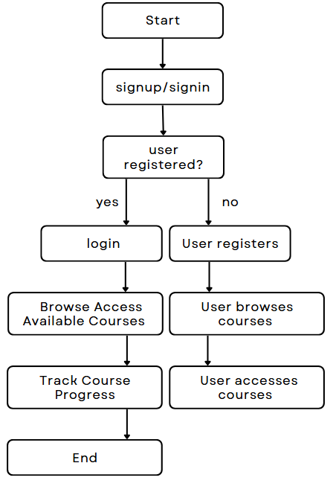

CHAPTER 5
SYSTEM IMPLEMENTATION

5.1 Introduction

System implementation is a critical phase in the development lifecycle where design plans are translated into a functional application. For the Study Buddy project, this phase includes setting up the MERN (MongoDB, Express.js, React.js, Node.js) stack, integrating essential features, and ensuring that the application fulfills the defined objectives. The implementation is a systematic approach to achieving a robust and efficient platform tailored to student needs. This chapter elaborates on the various steps and methodologies employed to bring Study Buddy to life, focusing on seamless functionality, user experience, and system reliability.

5.2 Implementation of Proposed Methodology

The implementation of the proposed methodology involved several structured steps:
Setting up the Development Environment The first step in implementation was configuring the development environment. This included installing and setting up Node.js, MongoDB, and the React development environment. Tools like Visual Studio Code and Postman were utilized for efficient coding and API testing. The environment was optimized for collaborative development, using Git for version control and ensuring a streamlined workflow.
Creating the Frontend Using React.js React.js was chosen for its component-based architecture and dynamic capabilities. The frontend was designed to provide an intuitive user interface (UI) with responsiveness to various device sizes. Features such as course browsing, enrollment options, and progress tracking were implemented. Reusable components like navigation bars, course cards, and dashboards ensured a modular and scalable frontend structure.
Building the Backend with Node.js and Express.js The backend was developed using Node.js and Express.js to handle server-side logic and data processing. Express.js facilitated efficient API creation, allowing smooth communication between the client and the server. Key functionalities like user authentication, course management, and data retrieval were implemented, ensuring reliability and performance.

Integrating MongoDB for Data Storage and Management MongoDB served as the database for storing and managing application data. The database schema was designed to accommodate user information, course details, progress records, and feedback efficiently. Indexed queries and aggregation pipelines were used to optimize data retrieval and ensure scalability as the platform grows.
Implementing Authentication and Authorization Mechanisms Secure authentication and authorization mechanisms were critical to safeguarding user data. The application employed JSON Web Tokens (JWT) for session management, ensuring that users could securely access their accounts and interact with the platform. Role-based access control was implemented to differentiate between student and admin functionalities.
Developing APIs for Seamless Communication The backend included RESTful APIs to facilitate seamless communication between the frontend and backend. These APIs were designed to handle operations such as user registration, course enrollment, and progress updates. Standard HTTP methods (GET, POST, PUT, DELETE) were used for clear and maintainable API endpoints.
Testing and Debugging the Application Comprehensive testing was conducted to ensure the application’s functionality and performance. Unit tests verified individual components, while integration tests ensured the coherence of the entire system. Tools like Jest and Mocha were employed for automated testing, and manual testing was conducted to simulate real-world scenarios. Debugging processes addressed issues such as performance bottlenecks and minor UI inconsistencies.
This structured implementation approach ensured that Study Buddy emerged as a robust, efficient, and user-friendly platform that aligns with its objectives and user expectations.

CHAPTER 6
RESULTS AND DISCUSSION

The implementation of the Study Buddy project yielded a fully functional web application that meets its defined objectives. The platform offers students a centralized hub to explore, enroll in, and track their progress across various courses. The following results were observed:
Responsive User Interface The application provides a responsive and visually appealing user interface. It adapts seamlessly to devices of varying screen sizes, ensuring an optimal user experience across desktops, tablets, and smartphones.
Efficient Course Management The platform facilitates efficient course management for both students and administrators. Students can easily browse through available courses, enroll, and monitor their progress. Administrators can add, update, and manage courses through an intuitive admin panel.
Real-Time Progress Tracking The application includes a progress tracker that provides students with real-time insights into their learning journey. This feature motivates users to stay consistent and achieve their academic goals.
Seamless Backend Integration The APIs developed for backend integration proved reliable and efficient, enabling smooth data flow and quick responses to user actions. This ensured a lag-free and interactive user experience.

CONCLUSION WITH FUTURE ENHANCEMENTS

In conclusion, Study Buddy achieves its goal of creating a centralized platform for students to explore, enroll in, and track their progress across various courses. The project’s success underscores the potential of the MERN stack in developing scalable and efficient web applications. Future enhancements could include integrating advanced analytics for personalized recommendations, adding support for multimedia content, and incorporating gamification elements to further enhance user engagement. These improvements would ensure that Study Buddy continues to meet the evolving needs of students and remains a valuable tool in the education sector.

BIBLIOGRAPHY

- Node.js Documentation: https://nodejs.org/en/docs/
- React.js Documentation: https://reactjs.org/docs/getting-started.html
- MongoDB Documentation: https://www.mongodb.com/docs/
- Express.js Documentation: https://expressjs.com/
- MERN Stack Tutorials and References

